LINEAR REGRESSION- REPORT
Regression analysis deals with identifying relationships among variables and uses these to make out predictions. Outcomes and the predictions are linearly dependent i.e. the variables change constantly with respect to other.

Regression model
Y- dependent variable, X_{i}s- independent variables. B₀- calculated with regression softwares using data by implementing various mathematical formulas.
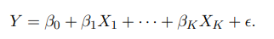
Regression gives us the best line through the data and uses least square criterion.
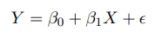
The predicted value of Yi will be different from the observed value and the difference between the two is Error or Residual.
Bo ans B1 is to minimize the sum of squares errors.
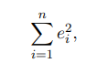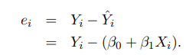
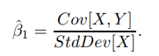-slope
The regression picks the line out of all the lines that has minimum sum of square errors.

ASSUMPTIONS FOR LEAST SQUARES
- The errors are independent of Xs
- The expected values of errors is Zero
- All errors have same variance
- The errors are not correlated.
- It becomes an issue if we correlate the errors for forecasting. Because we may introduce overlapping of several periods which will violate the 4th assumption.

ANOVA table- Analysis Of Variance. This table divides the variability into explained and unexplained parts.
High R² (called coefficient of determination or R- square) indicates strong linear relationship b/w variables.
R²= explained variability/total variability
=SSR/SST
And,
SST=SSR+SSE,
where SSR is the sum of squared residuals, SSE is the sum of squared estimate of errors and SST is the total sum of squared.

Evaluating the estimated slope
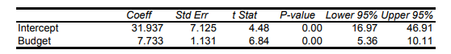
B₀ and B₁ are the coeff.
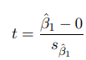 t stands for test stastistics. The s_{b1} is estimated standard error wrt B_{1.}
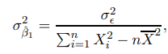 where the LHS is variance of error. P-value is very very small and should be very small for a model, and if not means we have included the non relevant dependent variable.

Making Predictions
Difference should be kept in mind while making predictions between the expected values and individual values.
For eg, between selling price(individual values) and average selling price (ecpected)

Multiple Regression
Using more than one type of variable but which are explanatory and are not redundant is what we use in multiple regressions.
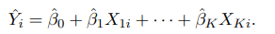
Multicollinearity is the redundancy among the explanatory variable. It is not necessary to include all the variables for a perfect model.

Dummy variables
Variables in regression are often categorical. Dummy variables are used to incorporate such variables.
Such variables are taken to be 0 or 1. And for m variables, we take m-1 variables.

Reference- https://www0.gsb.columbia.edu/faculty/pglasserman/B6014/Regression.pdf

